ASSIST FOR POLICEMEN

PROJECT REPORT

Submitted by

GIRIDARAN.T. P (191EC140)
giridaran.ec19@bitsathy.ac.in



DEPARTMENT OF ELECTRONICS AND COMMUNICATION ENGINEERING
BANNARI AMMAN INSTITUTE OF TECHNOLOGY
(An Autonomous Institution Affiliated to Anna University, Chennai)
SATHYAMANGALAM - 638401.

MAY 2020

TABLE OF CONTENTS:
CHAPTER NO | CONTENT | PAGE NO
1 | ABSTRACT | 3
2 | INTRODUCTION | 4
3 | EXISTING SYSTEM | 5
4 | PROPOSED SYSTEM | 7
5 | WORKING | 9
6 | CONTROLLER | 10
7 | SENSORS | 14
8 | CLOUD DATA | 18
9 | OUTPUT | 19
10 | APPLICATIONS | 20
11 | CONCLUSION | 20
12 | REFERENCES | 21
ABSTRACT

The major problem all over the world is a viral infection named COVID-19. This infection has made the entire world to shut down. The economy of the countries all over the world had decreased more. Many lives of people were taken away by this deadly virus. This infection spreads by contact transmission, that is contact with the infected person. This virus first detected in China and then spread all over the world. The beta coronavirus that causes COVID-19 is SARS-CoV-2. SARS-CoV-2 appears to have its origin in bats. Still today there is no medicine for COVID-19. India is also a prey to this virus.
Many researchers are doing experiments to find the nature of COVID-19. So, there is an urgent need to stop spreading this deadly infection. Many people sacrifice their lives to secure others. The doctors, Policemen and Social workers plays a vital role during this period. I think their lives also to be saved. So, this is a Vehicle model which can reduce the work pressure of these people effectively. This model can be used for detection of this infection and control the area which is under lockdown. This model is an unmanned vehicle which can also warn the people who roam around and can be able to detect whether they roam often will be recorded automatically. And, it can also help the social workers by informing the areas which is unclean. This will useful to save the lives of people who sacrifice their lives to others.

INTRODUCTION
Corona virus disease (COVID-19) is an infectious disease caused by a newly discovered corona virus. Most people infected with the COVID-19 virus will experience mild to moderate respiratory illness and recover without requiring special treatment. Older people, and those with underlying medical problems like cardiovascular disease, diabetes, chronic respiratory disease, and cancer are more likely to develop serious illness.
At this time, there are no specific vaccines or treatments for COVID-19. The virus that causes COVID-19 and the one that caused the outbreak of Severe Acute Respiratory Syndrome (SARS) in 2003 are related to each other genetically, but the diseases they cause are quite different. The most common symptoms of COVID-19 are fever, tiredness, and dry cough. Some patients may have aches and pains, nasal congestion, runny nose, sore throat or diarrhoea. These symptoms are usually mild and begin gradually. There is no specific treatment for disease caused by a novel coronavirus.
However, many of the symptoms can be treated and therefore treatment based on the patient's clinical condition. Standard recommendations to prevent the spread of COVID-19 include frequent cleaning of hands using alcohol-based hand rub or soap and water; covering the nose and mouth with a flexed elbow or disposable tissue when coughing and sneezing; and avoiding close contact with anyone that has a fever and cough. Currently, there is no vaccine available to protect against 2019- novel Corona Virus. Almost all the countries were affected and many lives of people were taken away.
It is better to be safe before it infects. Prevention is better than cure. This model helps to be preventive and can reduce work pressure of humans. This device can control the area under lockdown and can regulate the traffic. This model plays an important role in prevention.
EXISTING SYSTEM
"The city police are now conducting trials of the camera installation process and the city will soon see fever detection thermal cameras installed in various areas,” said a press note issued by the Mumbai City Police. The thermal detection camera will detect individuals with high body temperatures to find suspected virus carriers. The discussions on the implementation in Mumbai are on, after which a decision on replicating it same in other cities, if required, would be taken, said the statement.
Anil Deshmukh, home minister, government of Maharashtra, told media, “The state government is in talks with Larsen & Toubro and Mumbai police for the installation of the fever detection thermal cameras, which can help detect high body temperature." In Mumbai, L&T has been working on installation and operation of CCTVs along with the Bombay Municipal Corporation’s Disaster Management Cell. He further stated, “While the whole state is in a turmoil due to the epidemic of corona, we are looking at industries to help us tackle the need for masks, ventilators and personal protective equipment.”
The fever detection thermal surveillance system has been already used in China and other countries to combat the spread of the COVID-19 virus. The CCTVs and video analytics are being used to monitor 241 containment zones in the city, where positive cases have been ascertained. In a statement, L&T said it is helping the authorities combat covid-19 through drone-based surveillance to keep an eye on crowd formation and fever detection using thermal cameras at Mumbai.
As part of their ongoing efforts to contain the spread of coronavirus, the Telangana police are now deploying Artificial Intelligence (AI) to enforce the compulsory wearing of face mask in public. With Telangana on Monday recording the largest single-day surge in SARS-CoV-2 cases since the outbreak of the pandemic, chief minister K. Chandrashekhar Rao has instructed the officials of various departments including police to adopt stringent measures to bring the situation under total control at the earliest. Despite their untiring efforts to ensure that the lockdown rules are strictly followed by the people, the compulsory wearing of face mask in public is violated more often than not. The government has stipulated a penalty of Rs1,000 for not wearing face mask outdoors.
The rule was already in force in gram panchayats and municipalities for quite some time now, but not many violators were penalised as it is beyond the police capacity to catch hold of each and every person violating the rule.
AI integrated with surveillance system
The technology wing of the police department has come up with a solution to this challenge using AI. The solution, said to be the first of its kind, will be rolled out this week in Hyderabad, Cyberabad, and Rachakonda Commissionerate limits. The software tool is linked to CCTV cameras installed across the city to identify face mask rule violators. Cameras will flag those not wearing the masks and an alert will be sent to the central command control centre at the state police headquarters. This will be passed on to patrolling personnel to trace the violators either riding bikes or walking on foot.
Integrated with the surveillance technology, the new tool is able to identify violators, however, some discrepancies that came up during the test runs are being rectified, according to sources in the department. The team has now integrated machine learning into the tool to detect various kinds of masks, towels and handkerchiefs of different colors and with designs. A similar system is already in use to identify violators of traffic rules and 3-km limit violators by recognizing the vehicle number plates.
"But, identifying various types of masks is difficult. The system can detect the people without masks. Some changes are being made to it, as people are using different colors and models of masks,” the official said.
“Despite a wide range of awareness programmes, people are still negligent about the necessity of using a mask. Our aim is, more than penalizing, to create awareness and thereby enforcing the rule with their cooperation," he said.
The software will send the exact location details where a person is spotted without a face mask and the police personnel on the patrol will jump into action to catch hold of the violator.
PROPOSED SYSTEM
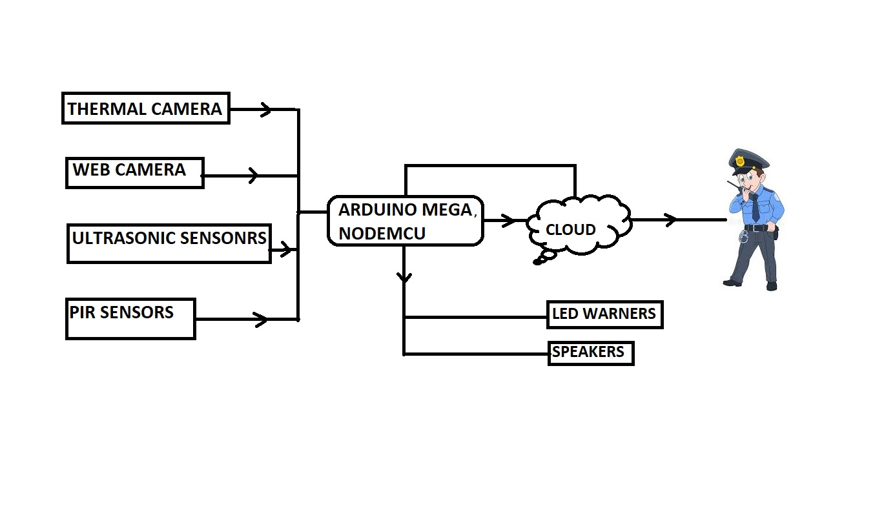
BLOCK DIAGRAM:
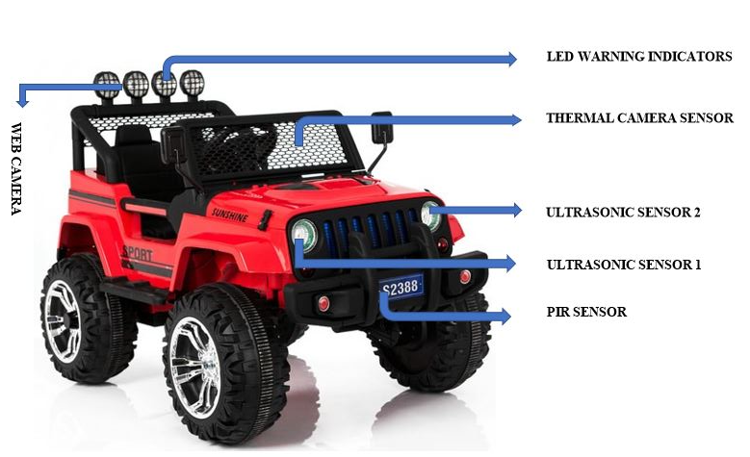
WORKING:
The thermal camera sensor and the web camera are placed at the front of the vehicle. The PIR motion sensor is placed at the front bottom of the vehicle. The motion of objects is detected by PIR sensor and the continuous recording is done by using web camera. The thermal sensor is used to detect the temperature of humans. The ultrasonic sensors are used to detect the distance of objects which are placed in front of the vehicle.
The thermal imaging sensor is a one kind of sensor used to determine an image based on the absolute temperature of the object. The image is formed based on the object’s heat signature. By using the web camera, we can continuously monitor the happenings in the surroundings. For safety locomotion the ultrasonic sensor can be used. The data collected from all the sensors and camera are transferred to cloud using the Wi-Fi module ESP8266. The entire setup can be controlled using cloud. Also, the buzzers are also linked with the buzzers and led warning indicators using Arduino mega. The entire setup is connected to Arduino board.

COMPONENTS REQUIRED:

- Thermal camera sensor
- Web camera
- PIR motion sensor
- Ultrasonic sensors
- Led indicators
- Arduino mega
- Buzzers
- Node MCU

CONTROLLER
ARDUINO MEGA:
Arduino is neither a microprocessor nor a microcontroller. It is simply a development board. Generally, board provides complete access to functions of microcontroller or microprocessor like to program the controller, to use the input/output pins, to communicate.
The Arduino Mega is a microcontroller board based on the ATmega2560. It has 54 digital input/output pins (of which 14 can be used as PWM outputs), 16 analog inputs, 4 UARTs (hardware serial ports), a 16 MHz crystal oscillator, a USB connection, a power jack, an ICSP header, and a reset button.
An Arduino Uno board is best suited for beginners who have just started using microcontrollers, on the other hand, Arduino Mega board is for enthusiasts who require a lot of I/O pins for their projects. The 8-bit board with 54 digital pins, 16 analog inputs, and 4 serial ports. The Arduino Mega 2560 is a microcontroller board based on the ATmega2560.
The frequency/clock speed on these boards simply means how fast it can execute commands. It was a nice surprise to see that they all have the same clock speed at 16 MHz The Flash memory on the Uno and Micro are the same at 32 kB, while the Mega 2560 has 256 kB, giving it 8x more memory space.
WBoard Pro Arduino MEGA ESP8266 Wi-Fi Development Board for Arduino. WBoard Pro is a Wi-Fi development board based on Arduino MEGA. With an on-board ESP8266 chip (Wi-Fi firmware has been burnt in), you can drive ESP8266 to connect Wi-Fi and visit the internet by controlling the serial ports.
Arduino can be used to develop stand-alone interactive objects or can be connected to software on your computer (e.g. Flash, Processing, MaxMSP). The open-source IDE can be downloaded for free (currently for Mac OS X, Windows, and Linux). The Arduino Mega is a microcontroller board based on the ATmega2560.
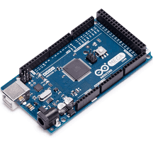
ARDUINO MEGA 2560
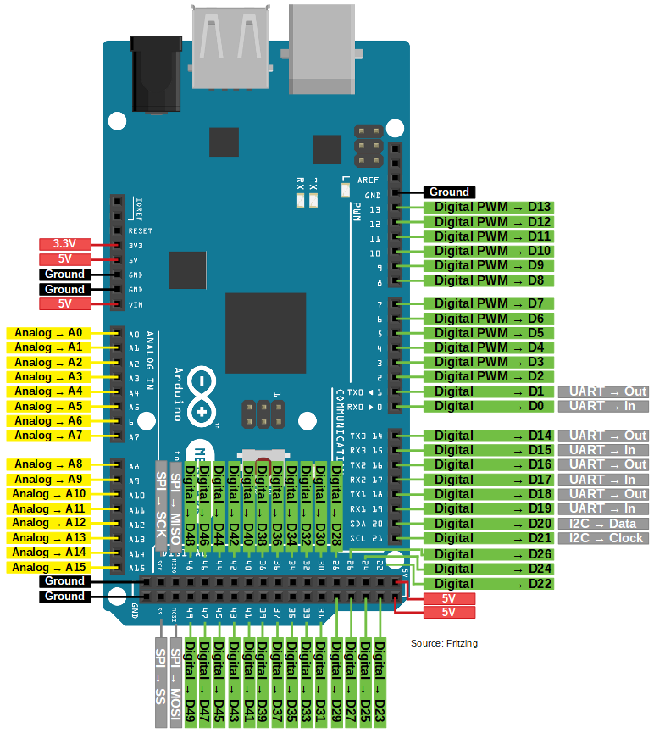
ESP8266:
The ESP8266 is a low-cost Wi-Fi microchip, with a full TCP/IP stack and microcontroller capability, produced by Espressif Systems in Shanghai, China. The ESP8285 is an ESP8266 with 1 MiB of built-in flash, allowing the building of single-chip devices capable of connecting to Wi-Fi.
The ESP8266 WiFi Module is a self-contained SOC with integrated TCP/IP protocol stack that can give any microcontroller access to your WiFi network. The ESP8266 is capable of either hosting an application or offloading all Wi-Fi networking functions from another application processor.
NodeMCU is an open-source firmware and development kit that helps you to prototype or build IoT products. It includes firmware that runs on the ESP8266 Wi-Fi SoC from Espressif Systems, and hardware which is based on the ESP-12 module. It is based on the eLua project and built on the Espressif Non-OS SDK for ESP8266.
Connecting to the WiFi module through a TPLink WR841N router, [CN] as able to ping the module at 479 meters with a huge rubber duck antenna soldered on, or 366 meters with the PCB antenna.
Open the Serial Monitor window from the Arduino IDE and change the following settings at the bottom of the Serial Monitor window: Both NL & CR – send both a newline and carriage return character at the end of a command. 115200 baud – baud rate of communication set to 115200.
The very low price and the fact that there were very few external components on the module, which suggested that it could eventually be very inexpensive in volume, attracted many hackers to explore the module, the chip, and the software on it, as well as to translate the Chinese documentation

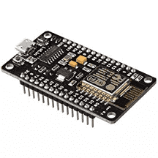
NODEMCU-ESP8266
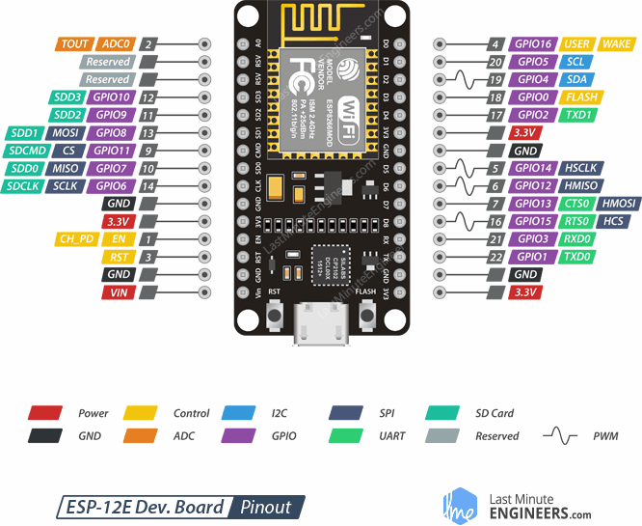
SENSORS
ULTRASONIC SENSOR:
An ultrasonic sensor is an instrument that measures the distance to an object using ultrasonic sound waves. An ultrasonic sensor uses a transducer to send and receive ultrasonic pulses that relay back information about an object's proximity.
An ultrasonic sensor is an electronic device that measures the distance of a target object by emitting ultrasonic sound waves, and converts the reflected sound into an electrical signal.
Ultrasonic waves travel faster than the speed of audible sound (i.e. the sound that humans can hear). The maximum range of our products is presently 20 meters (about 70 feet) and varies by model. The distance at which an object is detected depends on its size, shape and orientation.
Ultrasonic sensors work by emitting sound waves at a frequency too high for humans to hear. They then wait for the sound to be reflected back, calculating distance based on the time required. This is similar to how radar measures the time it takes a radio wave to return after hitting an object.
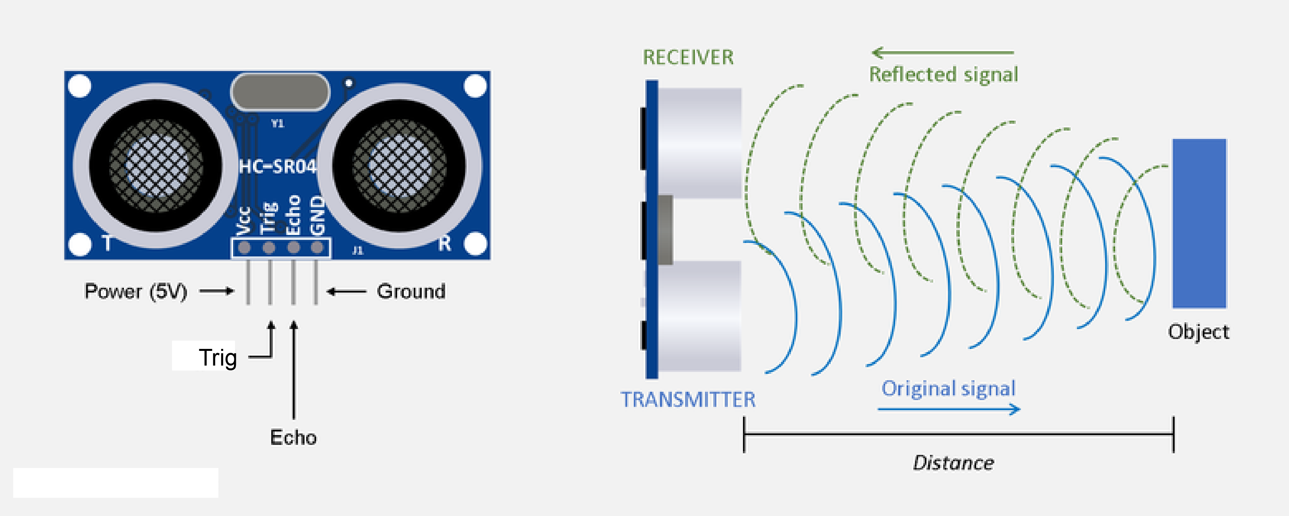
Occupational exposure to ultrasound in excess of 120 dB may lead to hearing loss. Exposure in excess of 155 dB may produce heating effects that are harmful to the human body, and it has been calculated that exposures above 180 dB may lead to death.
PIR MOTION SENSOR:
A passive infrared sensor (PIR sensor) is an electronic sensor that measures infrared (IR) light radiating from objects in its field of view. They are most often used in PIR-based motion detectors. PIR sensors are commonly used in security alarms and automatic lighting applications. The PIR sensor itself has two slots in it, each slot is made of a special material that is sensitive to IR.
When a warm body like a human or animal passes by, it first intercepts one half of the PIR sensor, which causes a positive differential change between the two halves. When selecting this method motion is triggered based on a certain percentage of pixel change.
In this case motion is detected by means of a PIR sensor, a passive infrared sensor. This sensor detects emitted infrared energy from objects (humans and animals, but also cars) in the form of heat. When the PIR detects motion, the output pin will go "high" to 3.3V and light up the LED! Once you have the breadboard wired up, insert batteries and wait 30-60 seconds for the PIR to 'stabilize'.
PIR sensor detects a human being moving around within approximately 10m from the sensor. This is an average value, as the actual detection range is between 5m and 12m. PIR are fundamentally made of a pyro electric sensor, which can detect levels of infrared radiation.
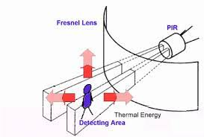
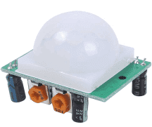
THERMAL CAMERA SENSOR:
Body temperature of those infected is expected to be around 38~39°C while adult human normal temperature should be around 36°C. Thermal imaging camera can visualize such temperature difference instantly from safe distance for you to segregate those who may have been infected.
To detect thermal energy, special FPAs (Focal Plane Arrays) are required. These can be divided into two types, cooled and uncooled detectors. Cooled detectors exist to maximize detection performance. Thermal imaging is simply the process of converting infrared (IR) radiation (heat) into visible images that depict the spatial distribution of temperature differences in a scene viewed by a thermal camera.
Thermal cameras are still surveillance cameras. Experts are now concluding that thermal imaging from a distance—including that in camera systems that claim to detect fevers—may not be effective. The cameras typically only have an accuracy of +/- 2 degrees Celsius (approximately +/- 4 degrees Fahrenheit) at best.

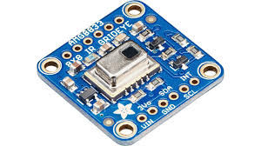
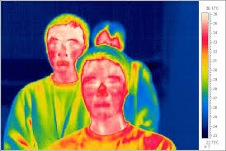

CAMERA MODULE:
OV7670 Camera Module is a precise small size, high sensitive and low voltage CMOS image Sensor module for capturing and processing the image. It is based on OV7670 image sensor. Through SCCB bus control, the sensor can output the whole frame, sampling, and various resolution of 8 bits of data.
The product VGA image can reach up to a maximum of 30 frames per second. Users can completely control the image quality, data format and transmission mode. All the process of image processing functions can be through the SCCB programming interface, including gamma curve, white balance, saturation and chroma.
The OV7670 is a low-cost image sensor DSP that can operate at a maximum of 30 fps and 640 x 480 ("VGA") resolutions, equivalent to 0.3 Megapixels. The captured image can be pre-processed by the DSP before sending it out. This pre-processing can be configured via the Serial Camera Control Bus (SCCB).
In addition, OmmiVision image sensor has been in application of unique sensor technology, by reducing or eliminating the optical or electronic defect such as fixed pattern noise, tail, floating away, etc., to improve the quality of the image, and get the clear and stable color images.
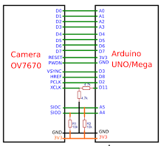
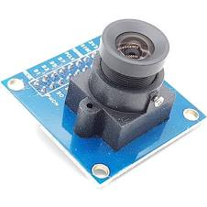

CLOUD DATABASE:
A cloud database is a database that typically runs on a cloud computing platform, and access to the database is provided as-a-service. Database services take care of scalability and high availability of the database. Database services make the underlying software-stack transparent to the user.
Cloud platforms allow users to purchase virtual-machine instances for a limited time, and one can run a database on such virtual machines. Users can either upload their own machine image with a database installed on it, or use ready-made machine images that already include an optimized installation of a database.
With a database as a service model, application owners do not have to install and maintain the database themselves. Instead, the database service provider takes responsibility for installing and maintaining the database, and application owners are charged according to their usage of the service. This is a type of SaaS - Software as a Service.
- SQL databases are one type of database which can run in the cloud, either in a virtual machine or as a service, depending on the vendor. While SQL databases are easily vertically scalable, horizontal scalability poses a challenge, that cloud database services based on SQL have started to address.
- NoSQL databases are another type of database which can run in the cloud. NoSQL databases are built to service heavy read/write loads and can scale up and down easily,^{[7]} and therefore they are more natively suited to running in the cloud. However, most contemporary applications are built around an SQL data model, so working with NoSQL databases often requires a complete rewrite of application code. Some SQL databases have developed NoSQL capabilities including JSON, binary JSON (e.g. BSON or similar variants), and key-value store data types.

OUTPUT:

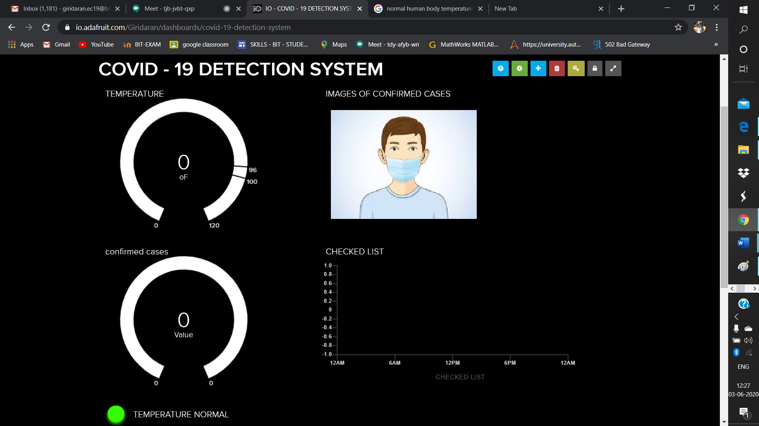
APPLICATION:
This vehicle can be used to visualize the areas under lockdown. This vehicle can also be used in Traffic control. Instead of Policemen it can be used to regulate the roamers in the roads. Using thermal camera sensor, it can be used to detect the temperature of the roamers and the people under lockdown. The web camera can continuously record the entire activity in the traffic. It can warn the roamers by an attachment of warning LED and buzzers. It can also help the social workers by monitoring the areas which is to be cleaned. This can record all the vehicles passed and can report the entire history to the policemen. There is no need of Policemen to stay out and monitor the out comers. It is work friendly; they can control this vehicle from their home. They can warn the roamers by an attachment of speaker connected model and warn them to stay at home. This can reduce the work pressure of policemen and can save the time of social workers. It is also helpful to detect the temperature of the people without human contact.

CONCLUSION:
Prevention is better than cure. Using this many lives can be saved. The work pressure of the people who sacrifices their life to others can be reduced. Little change can bring a great profit to our nation. It is better to stay safe before it affects.

REFERENCES:
- WORLD HEALTH ORGANISATION
https://www.who.int/docs/default-source/coronaviruse/situation-reports/20200227-sitrep-38-covid-19.pdf
- HINDUSTANTIMES
https://www.hindustantimes.com/india-news/mumbai-12-police-personnel-from-oshiwara-police-station-test-positive-for-covid-19/story-Ea6ATiqTAJcNysyITBkriM.html
- ECONOMICTIMES
https://government.economictimes.indiatimes.com/news/technology/telangana-as-covid-19-cases-surge-police-to-deploy-ai-to-detect-face-mask-rule-violators-in-hyderabad/75695200
- CIRCUITDIGEST
https://circuitdigest.com/project/arduino-thermal-imaging-camera
- ADAFRUIT
https://learn.adafruit.com/

