

PLASTIC WASTE MANAGEMENT

A MINI PROJECT REPORT

Submitted by

AISWARYA S K | [20EC002]
AMRUTHAVARSHINI S | [20EC005]
DIVYA V | [20EC036]
ATHISHA M | [20EC011]

BACHELOR OF ENGINEERING

in
ELECTRONICS AND COMMUNICATION ENGINEERING

Sri Eshwar College of Engineering
(An Autonomous Institution)
COIMBATORE – 641 202

MAY 2022
BONAFIDE CERTIFICATE

Certified that this mini project report “PLASTIC WASTE MANAGEMENT” is the bonafide work of

AISWARYA S K | [20EC002]
AMRUTHAVARSHINI S | [20EC005]
DIVYA | [20EC036]
ATHISHA | [20EC011]

who carried out the project work under my supervision

…………………………………  SIGNATURE  Dr. N. Shanmugasundaram,  M.E., Ph.D.,  HEAD OF THE DEPARTMENT  Professor & Head,  Department of ECE,  Sri Eshwar College of Engineering,  Kinathukadavu,  Coimbatore-641202. | …………………………………  SIGNATURE  Mr. E. VENUGOPAL,  M.E., Ph.D.,  SUPERVISOR  Assistant Professor,  Department of ECE,  Sri Eshwar College of Engineering,  Kinathukadavu,  Coimbatore-641202.
Submitted for the End Semester practical examination – Mini project work viva-voce held on _ _ _ _ _ _ _ _ _ _ _ _

……………………… ………………………

(Internal Examiner) (External Examiner)

 | TABLE OF CONTENTS
CHAPTER No. | TITLE |  | PAGE No.
 | ABSTRACT |  | i
 | LIST OF FIGURES |  | ii
 | LIST OF ABREVATIONS |  | iii
1 | INTRODUCTION |  | 1
2 | LITERATURE SURVEY |  | 2
 | 2.1 | EXISTING PRODUCT | 2
 | 2.2 | PROBLEM STATEMENT | 4
3 | PROPOSED SOLUTION |  | 5
 | 3.1 OVERVIEW |  | 5
 | 3.2 BLOCK DIAGRAM |  | 5
4 | HARDWAE DESCRIPTION
 | 4.1 | OVERVIEW | 6
5 | SOFTWARE DESCRIPTION |  | 9
 | 5.1 | PROCEDURE TO CREATE A PROJECT | 9
 | 5.2 | CODING STRUCTURE | 10
6 | RESULT AND IMPLEMENTATIONS |  | 12
7 | CONCLUSION AND FUTURE SCOPE |  | 13
 | REFERENCE |  | 14

ABSTRACT
The massive consumption of a wide range plastic products has
generated a huge amount of plastic waste. There is a need to provide awareness
of their uses and routine management as a part of our lifestyle. Nowadays,
plastics are increasingly being used in our daily life activities, including the
packaging in different food and brewing companies, cosmetics, pharmaceutical,
and other production sectors need to pack their end products for efficient and
safer product's delivery to the community. Recycling of plastics into new
source. Plastics are collected from home products (shampoo cover, plastic cover) and are converted into renewable.
Renewable plastics are recycled into new product. there is seven
types of plastics. Among that PET and HDFE are the two types of plastics
mostly used in day to day life. Landfills, Pyrolysis, recycling, bioremediation,
Incineration are the methods can be used for plastic waste management.
Among these recycling is the best method to recycle the plastics. because other
methods would take more time and process is so lengthy. Moreover, the product
from those process cannot be recycled for many times. So recycling is the best
method to recycle PET and HDFE. Collecting the plastics from the household.
Sorting them into type needed for the recycling. Shredding is the main process
to cut the plastics into pieces. The cut pieces of plastics are taken by the
conveyor belt. The washing is the method to wash and dry the plastic pieces.
The melting is the used to heat and melt the plastic at constant temperature. The
new recycled product is obtained. The recycling plastics can be recycled into at
least ten times. In Canada researchers are going on developing these plastics
into a new renewable by product.

i

LIST OF FIGURES

FIGURE NO | TITLE | PAGE NO
1.1 | Process of recycling | 1
2.1 | Wood decking | 2
2.2 | Lamp made of plastics | 3
2.3 | Chairs made of plastics | 3
2.4 | Existing problem due to plastics | 4
3.2 | General architecture | 5
4.1 | Hardware used in project | 6
4.2 | Relay module | 7
4.3 | Power supply | 7
4.4 | Node MCU | 8
4.5 | 200 rpm motor | 8
6.1 | Prototype of recycling | 12

ii
LIST OF ABBREVATIONS

1 | PET | Polyethylene  Terephthalate
2 | HDPE | High density  polyethylene
3 | PVC | Polyvinyl  chloride
4 | LDPE | Low density polyethylene
5 | PP | Polypropylene
6 | PS | Polystyrene
7 | PC/PA | Polycarbonate  /Polyamide

iii

CHAPTER 1
INTRODUCTION

As plastic is non-biodegradable in nature, it remains in environment
for several years and disposing plastic waste at landfill are unsafe since toxic
chemicals leach out into the soil, underground water and pollute the water
bodies. Therefore, plastic waste disposal is the major problem for the civic
authorities. Plastic recycling has been described as the process of recovering
scrap or waste plastics and reprocessing the material into useful products,
sometimes completely different in form from their original state.
Plastic recycling refers to the process of recovering waste or scrap
plastic and reprocessing the materials into functional and useful products. This
activity is known as the plastic recycling process. The goal of recycling plastic
is to reduce high rates of plastic pollution while putting less pressure on virgin
materials to produce brand new plastic products. This approach helps to
conserve resources and diverts plastics from landfills or unintended destinations
such as oceans.
Historically recycling in the plastic industry was carried out within
manufacturing companies as part of the standard production
process. In extrusion for instance, often where material and
contamination constraints allowed, in-house scrap would be re-
processed with virgin material, to improve ﬁnal material produc-
tion yields. Plastic waste both commercial and post consumer going
to landﬁll.
Therefore, it is only relatively late in the development of the
plastic industry that focus and public perception has shifted
towards the problems of plastic waste. This has been driven by
two factors; a growing concern about the costs, both ﬁnancial and
environmentally of land ﬁlling, and the sheer amount of plastic
waste ﬁnding its way into that waste stream.
This overview will provide a general introduction to the issues
affecting plastics recycling materials from end of life to disposal
and overview the main methods in landﬁll avoidance associated
with plastic wast
Historically recycling in the plastic industry was carried out within
manufacturing companies as part of the standard production
process. In extrusion for instance, often where material and
contamination constraints allowed, in-house scrap would be re-
processed with virgin material, to improve ﬁnal material produc-
tion yields. Plastic waste both commercial and post consumer going
to landﬁll.
Therefore, it is only relatively late in the development of the
plastic industry that focus and public perception has shifted
towards the problems of plastic waste. This has been driven by
two factors; a growing concern about the costs, both ﬁnancial and
environmentally of land ﬁlling, and the sheer amount of plastic
waste ﬁnding its way into that waste stream.
This overview will provide a general introduction to the issues
affecting plastics recycling materials from end of life to disposal
and overview the main methods in landﬁll avoidance associated
with plastic wast
Historically recycling in the plastic industry was carried out within
manufacturing companies as part of the standard production
process. In extrusion for instance, often where material and
contamination constraints allowed, in-house scrap would be re-
processed with virgin material, to improve ﬁnal material produc-
tion yields. Plastic waste both commercial and post consumer going
to landﬁll.
Therefore, it is only relatively late in the development of the
plastic industry that focus and public perception has shifted
towards the problems of plastic waste. This has been driven by
two factors; a growing concern about the costs, both ﬁnancial and
environmentally of land ﬁlling, and the sheer amount of plastic
waste ﬁnding its way into that waste stream.
This overview will provide a general introduction to the issues
affecting plastics recycling materials from end of life to disposal
and overview the main methods in landﬁll avoidance associated
with plastic waste
Historically recycling in the plastic industry was carried out within
manufacturing companies as part of the standard production
process. In extrusion for instance, often where material and
contamination constraints allowed, in-house scrap would be re-
processed with virgin material, to improve ﬁnal material produc-
tion yields. Plastic waste both commercial and post consumer going
to landﬁll.
Therefore, it is only relatively late in the development of the
plastic industry that focus and public perception has shifted
towards the problems of plastic waste. This has been driven by
two factors; a growing concern about the costs, both ﬁnancial and
environmentally of land ﬁlling, and the sheer amount of plastic
waste ﬁnding its way into that waste stream.
This overview will provide a general introduction to the issues
affecting plastics recycling materials from end of life to disposal
and overview the main methods in landﬁll avoidance associated
with plastic waste
Historically recycling in the plastic industry was carried out within
manufacturing companies as part of the standard production
process. In extrusion for instance, often where material and
contamination constraints allowed, in-house scrap would be re-
processed with virgin material, to improve ﬁnal material produc-
tion yields. Plastic waste both commercial and post consumer going
to landﬁll.
Therefore, it is only relatively late in the development of the
plastic industry that focus and public perception has shifted
towards the problems of plastic waste. This has been driven by
two factors; a growing concern about the costs, both ﬁnancial and
environmentally of land ﬁlling, and the sheer amount of plastic
waste ﬁnding its way into that waste stream.
This overview will provide a general introduction to the issues
affecting plastics recycling materials from end of life to disposal
and overview the main methods in landﬁll avoidance associated
with plastic waste
Historically recycling in the plastic industry was carried out within
manufacturing companies as part of the standard production
process. In extrusion for instance, often where material and
contamination constraints allowed, in-house scrap would be re-
processed with virgin material, to improve ﬁnal material produc-
tion yields. Plastic waste both commercial and post consumer going
to landﬁll.
Therefore, it is only relatively late in the development of the
plastic industry that focus and public perception has shifted
towards the problems of plastic waste. This has been driven by
two factors; a growing concern about the costs, both ﬁnancial and
environmentally of land ﬁlling, and the sheer amount of plastic
waste ﬁnding its way into that waste stream.
This overview will provide a general introduction to the issues
affecting plastics recycling materials from end of life to disposal
and overview the main methods in landﬁll avoidance associated
with plastic waste
Historically recycling in the plastic industry was carried out within
manufacturing companies as part of the standard production
process. In extrusion for instance, often where material and
contamination constraints allowed, in-house scrap would be re-
processed with virgin material, to improve ﬁnal material produc-
tion yields. Plastic waste both commercial and post consumer going
to landﬁll.
Therefore, it is only relatively late in the development of the
plastic industry that focus and public perception has shifted
towards the problems of plastic waste. This has been driven by
two factors; a growing concern about the costs, both ﬁnancial and
environmentally of land ﬁlling, and the sheer amount of plastic
waste ﬁnding its way into that waste stream.
This overview will provide a general introduction to the issues
affecting plastics recycling materials from end of life to disposal
and overview the main methods in landﬁll avoidance associated
with plastic waste
The simplest of plastic recycling processes involves collecting,
sorting, shredding, washing, melting, and pelletizing. The actual particular
processes vary based on plastic resin or type of plastic product.
FIGURE 1.1 PROCESSES OF RECYCLING
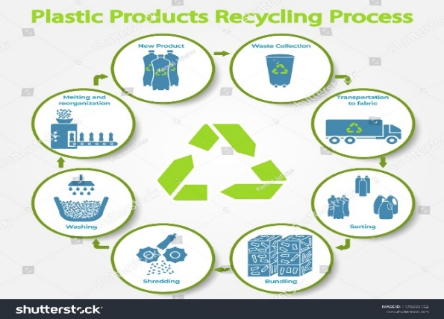 1
CHAPTER 2
LITERATURE SURVEY
2.1 EXISTING PRODUCT

Figure 2.1 wood decking
Wood decking is beautiful and versatile, but not very sustainable.
However, a Virginia-based company has developed a way to make ‘wooden’
decking almost entirely from waste products. The company turns reclaimed
sawdust and plastic bags into composite deck boards and is now one of the
largest plastic bag recyclers in the US.
Trex’s process is green from start to finish. Its proprietary processing method
first cleans plastic film and grinds it into granules. These are then combined
with sawdust reclaimed from factories, and the mixture is heated to give it a
soft, pliable consistency. Profile dies are used to form the mixture into boards,
which are cooled and cut to the desired length.
2

Figure 2.2 lamp



figure 2.3 chair made of waste plastics

3
2.2 PROBLEM STATEMENT
- Due to wastage of plastic it causes air pollution, water pollution etc.
- Due to that it also affects the health of human begins and causes
many health issues. Larger items, such as plastic bags and straws, can
choke and starve marine life, while smaller fragments (micro plastics) can
cause liver, reproductive, and gastrointestinal damage in animals.
- Secondly in forest region it affects animal’s life and growth of trees too
- The most visible impacts of plastic debris are the ingestion,
suffocation and entanglement of hundreds of marine species.
Marine wildlife such as seabirds, whales, fish and turtles
mistake plastic waste for prey; most then die of starvation as
their stomachs become filled with plastic
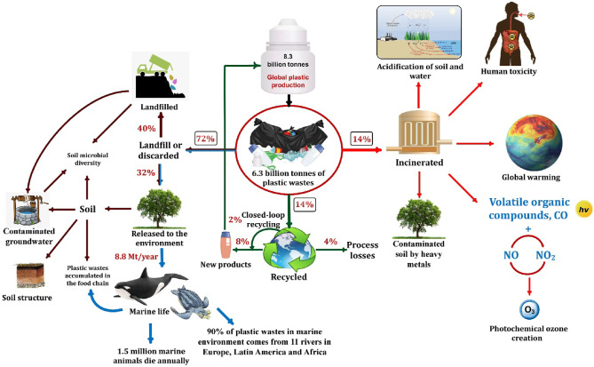 Figure 2.4 existing problem due to plastics 4
CHAPTER 3
PROPOSED SOLUTION
3.1 OVERVIEW
- Some methods are established to have a clean environment and good plastic waste disposal. They are landfills, incineration, bioremediation, recycling and pyrolysis.
- Recycling of plastics into new source. Plastics are collected from home and are converted into renewable.
- Renewable plastics are recycled to new product
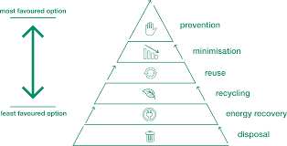

3.2. BLOCK DIAGRAM

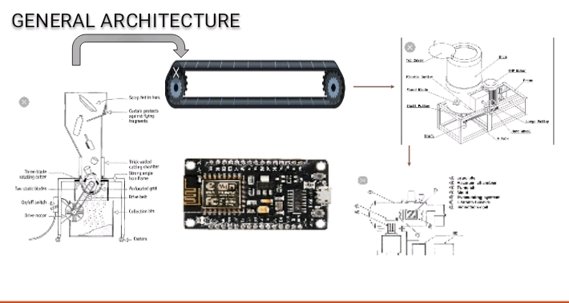
Figure 3.2 general architecture
5
CHAPTER 4
HARDWAE DESCRIPTION
4.1 OVERVIEW

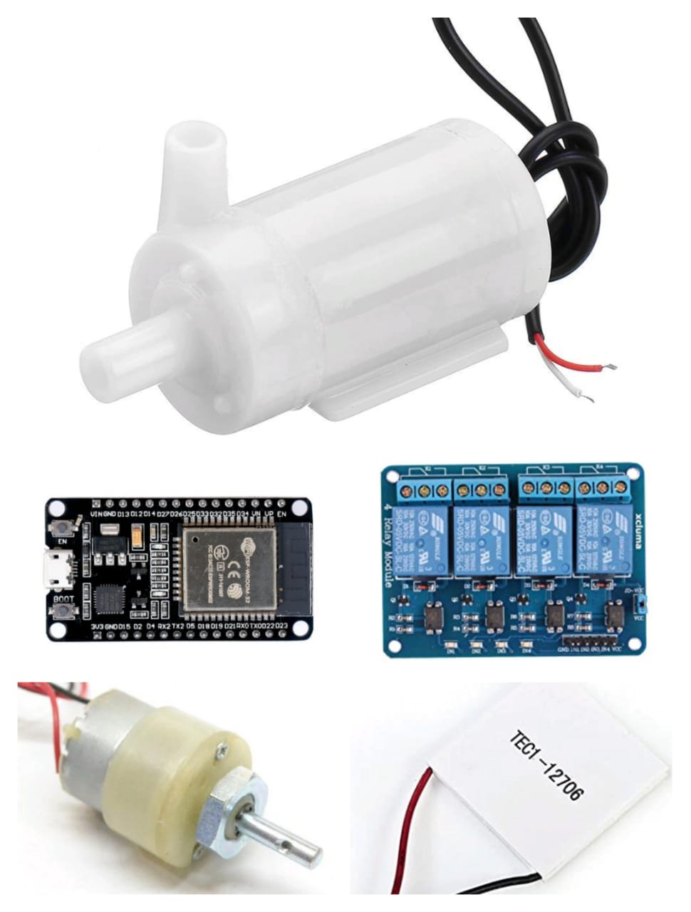

Figure 4.1 hardware used in recycling process
Relay module:
The 4 Channel Relay Module is a convenient board which can be
used to control high voltage, high current load such as motor, solenoid
valves, lamps and AC load. It is designed to interface with microcontroller
such as Arduino, PIC and etc. The relays terminal (COM, NO and NC) is being
brought out with screw terminal.

6

Figure 4.2 relay module
Power supply:
The 3.3- and 5-volts are typically used by digital circuits, while
the 12-volt is used to run motors in disk drives and fans.

Figure 4.3 power supply
Node MCU
Node MCU is a low-cost open source IOT platform. It initially included firmware which runs on the ESP8266 Wi-Fi SOC from Expressive Systems, and hardware which was based on the ESP-12 module. Node MCU is an open source platform based on ESP8266 which can connect objects and let data transfer using the Wi-Fi protocol. In addition, by providing some of the most important features of microcontrollers such as GPIO, PWM, ADC, and etc., it can solve many of the project's needs alone.

7

Figure 4.4 node MCU
Motor
Typical no load or synchronous speeds for an AC fractional horsepower
motor is 1800 or 3600 rpm, and 1000-5000 rpm for DC fractional HP motors.
If an application calls for a slower speed and/or higher torque, then a gear motor
should be considered
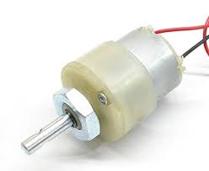
Figure 4.5 200 rpm motor

8
CHAPTER 5
SOFTWARE DESCRIPTION
5.1 PROCEDURE TO CREATE A PROJECT

In this part we are going to discuss about step by step of creating this
system
Step 1: Problem statement finding and declaration.
Step 2: Finding a standard solution to the problem statement.
Step 3: Making survey with the public about the solution developed.
Step 4: Finding the hardware’s to be used and getting known about them.
Step 5: Hardware assembly as the requirements for the system and making the
circuit connections.
Step 6: Making the requirements for the project
Step 7: Programming the node mcu with the requirements according to the
system and to make the hardware to communicate with machine
Step 8: Testing overall communication from the application to the hardware
and relay module and testing the relay module first with the battery powered
appliance.
Step 9: Finally testing the overall system with a real time appliance with the
power supply.
Step 10: Building the prototype and the system is ready 9

5.2 CODING STRUCTURE

sensor1 = D0;
int shredder = D1;
int conveyor = D2;
int washing =D3;

void setup () {
// put your setup code here, to run once:
pinMode (sensor1, INPUT);
pinMode (shredder, OUTPUT);
pinMode (conveyor, OUTPUT);
pinMode (washing, OUTPUT);
Serial.begin (115200);
}

void loop () {
// put your main code here, to run repeatedly:
int x = digitalRead(sensor1);
Serial.print(x);

if (digitalRead(sensor1) == 0)) 10
{
digitalWrite (D1, LOW);
Serial.print("Shredder OFF");
delay (1000);

}
else

{
digitalWrite (D1, HIGH);
Serial.print("Shredder ON");
//delay (100);
digitalWrite (D2, HIGH);
Serial.print("Conveyor ON");
//delay (5000);
digitalWrite (D3, HIGH);
Serial.print("Washing ON");
delay (100);

11

CHAPTER 6
RESULT AND IMPLEMENTATIONS

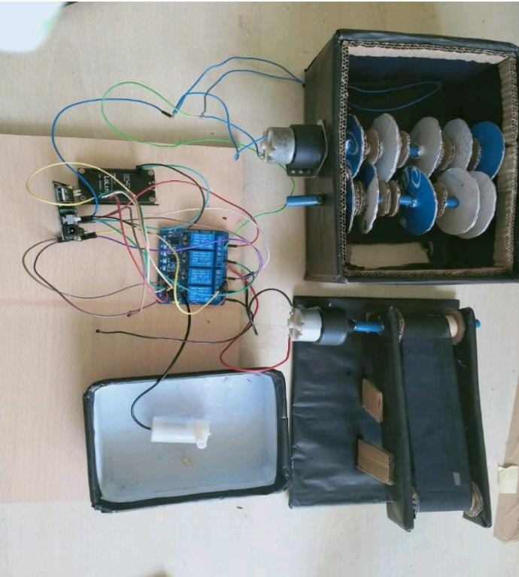

Figure 6.1 Prototype of recycling
12

CHAPTER 7
CONCLUSION AND FUTURE SCOPE
Together we must reduce, reuse and recycle. We can reduce by purchasing
items with the least amount of packaging and buying in bulk when appropriate.
We can reuse by avoiding disposable items. Finally, we can recycle by using
community recycling programs and purchasing products made from recycled
materials. Recycling waste saves over 30% of energy in the production of new
packaging or materials. Thanks to recycling, the consumption of raw materials
is reduced (which are already scarce in Spain and Europe). The ratio is greater
than 1 to 1. Recycling 1,000 kg of paper saves 12 trees from being felled. Pros
of plastics recycling are as follows: Reduction of pollution: Recycling
helps to reduce energy usage, consumption of virgin raw materials, air
and water pollution. Reduction of energy consumed by processing virgin
raw materials partially counterbalanced by energy consumed for
recycling. Three ongoing research directions have great potential to
advance plastic recycling practices: improving chemical recycling
efficiency and selectivity through catalyst development, minimizing the
need for sorting through compatibilizer design, and expanding recycling
beyond thermoplastics.

13

REFERENCES
1]https://journals.sagepub.com/doi/full/10.1177/0734242X211013428

2]https://www.researchgate.net/publication/350513815_PLASTIC_WASTE_MANAGEMENT
3]https://www.tandfonline.com/doi/abs/10.1080/03067319.2019.1686496
4]https://www.mdpi.com/journal/materials/special_issues/plastic_protection
5]https://www.journals.elsevier.com/renewable-and-sustainable-energy-reviews/call-for-papers/call-for-papers-on-sustainable-management-of-plastic-waste

14

8

